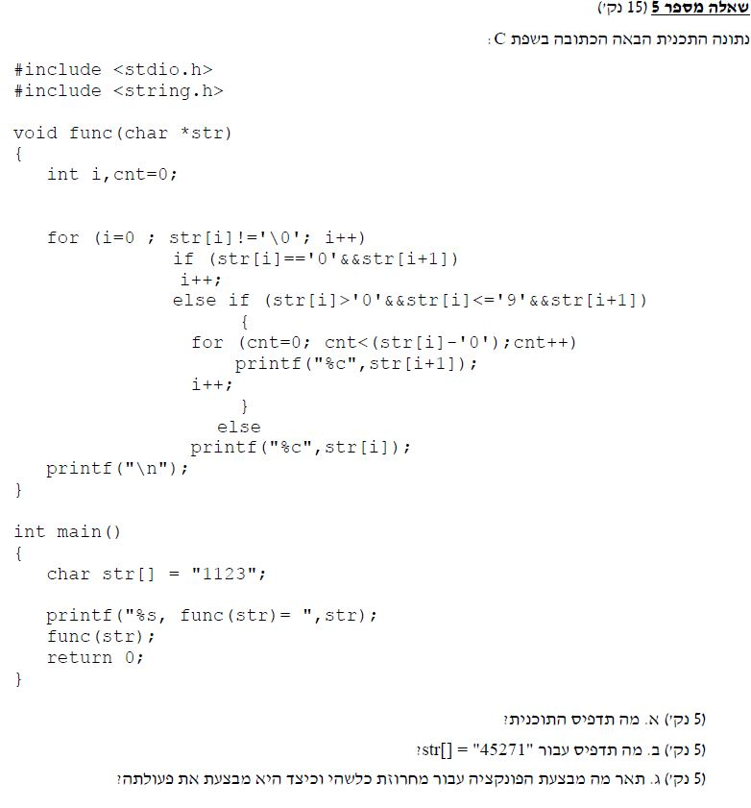

#include <stdio.h>

#include <string.h>

// Answer 5:

// This program will print for 1123: 133

// For 45271: 5555771

// The explanation: for each pair of numbers-

// the sec num will be printed in the amount of the first num.

// If the number is the last one, and doesn't have a pair -

// means the string is odd - it will be printed once in the end.

void func(char \*str)

{

int i, cnt = 0;

for (i = 0; str[i] != '\0'; i++)

if (str[i] == '0' && str[i + 1])

i++;

else if (str[i] > '0' && str[i] <= '9' && str[i + 1])

{

for (cnt = 0; cnt < (str[i] - '0'); cnt++)

printf("%c", str[i + 1]);

i++;

}

else

printf("%c", str[i]);

printf("\n");

}

int main()

{

//char str[] = "1123";

char str[] = "45271";

printf("%s, func(str) = ", str);

func(str);

getchar();

return 0;

}